


Abbots Green Academy Child Protection Procedures
Date: September 2025 Next review due by September 2026
Our designated safeguarding staff:
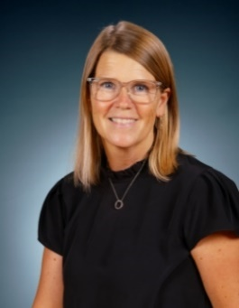 | Jo Uttley  Deputy Head teacher  Designated Safeguarding Lead (DSL)  Designated Teacher for looked-after and previously looked after children.  Tel: 01284 718818 |  | 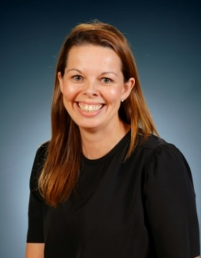 | Ang Morrison  Head teacher  DSL  Tel: 01284 718818
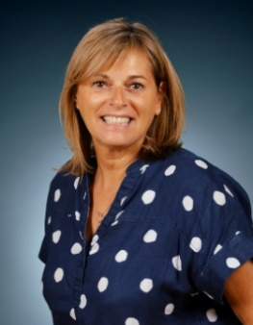 | 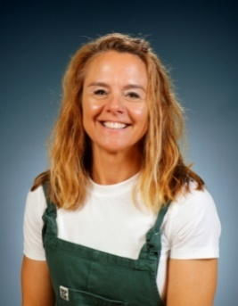 | 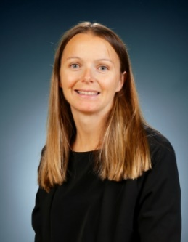 | 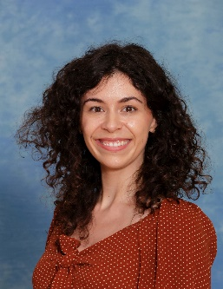 | 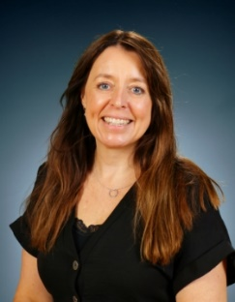
Laura Graham | Michelle Goodenough | Sharn Warren | Rebecca Hughes | Leda Yeaman
Children and Families Support Lead/DSL | Children and Families Support assistant/DSL | SENDCo/DSL  (currently on maternity leave) | SENDCo/DSL  (maternity leave cover) | Operations Manager/DSL
01284 718818 | 01284 718818 | 01284 718818 | 01284 718818 | 01284 718818
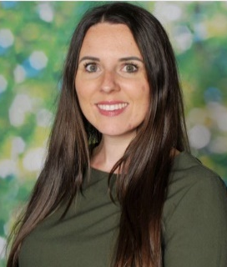 |  | 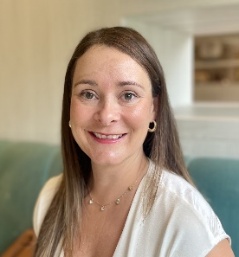 |  | 
Jenna Duncan | Ian Goodchild | Rebecca Clarke | Trust Safeguarding Lead | Trust Safeguarding Lead
Safeguarding Governor | Chair of the local governing body | Director of Education | Jemma Lynch | Steve Watts
01284 718818 | 01284 718818 | 01440 333400 | TrustDsl@unitysp.co.uk | TrustDsl@unitysp.co.uk

Aim
- Schools and their staff form part of the wider safeguarding system for children. Everyone who comes into contact with children and their families and carers has a role to play in keeping them safe. To fulfil this responsibility effectively, all professionals must ensure their approach is child-centred. This means that they must always consider what is in the best interests of the child.
- These procedures are for all staff, parents, governors, volunteers and the wider school community. They form part of the safeguarding arrangements for our school. They should be read in conjunction with the trust’s policies on safeguarding, safer recruitment and selection, staff code of conduct, health and safety, acceptable use of ICT and online safety, and the school’s policies on behaviour (including the anti-bullying strategy and approach to physical intervention) and educational visits policy. They should also be read in conjunction with Keeping Children Safe in Education (Department for Education). Safeguarding and promoting the welfare of children is defined in Keeping Children Safe in Education as:
  - Providing help and support to meet the needs of children as soon as problems emerge
  - protecting children from maltreatment, whether that is within or outside the home, including online
  - preventing impairment of children’s mental and physical health or development
  - ensuring that children grow up in circumstances consistent with the provision of safe and effective care
  - taking action to enable all children to have the best outcomes
Expectations
- All staff and volunteers must sign to confirm they have read and agree to these procedures before they start working with us, and whenever these procedures change. All children and their families will be provided with these procedures before enrolment. It is important for families to be aware of actions staff may take if there are any concerns for a child’s safety, and for them to understand that they might not be consulted before action is taken. Knowing about child protection procedures ahead of time helps parents to engage better in the process, meaning that change is more likely to take place.
- All adults working in our school who have contact with pupils are in positions of trust. Staff and volunteers should understand their responsibilities to safeguard and promote the welfare of pupils, including through early help. This means that staff and volunteers:
  - are responsible for their own actions and behaviour and must avoid any conduct which would lead any reasonable person to question their motivation or intentions
  - must work, and be seen to work, in an open and transparent way
  - must acknowledge that deliberately invented/malicious allegations are extremely rare and that all concerns should be reported and recorded
  - must discuss and/or take advice promptly from their line manager if they have acted in a way which may give rise to concern
  - must apply the same professional standards regardless of culture, disability, gender, language, racial origin, religious belief or sexual orientation
  - must not consume or be under the influence of alcohol or any substance, including prescribed medication, which may affect their ability to care for children
  - must be aware that breaches of the law and other professional guidelines could result in disciplinary action being taken against them, criminal action and/or other proceedings including barring by the Disclosure and Barring Service (DBS) from working in regulated activity, or for acts of serious misconduct prohibition from teaching by the Teaching Regulation Agency (TRA).
Early help
- Early help means providing support as soon as a problem emerges, at any point in a child’s life. Providing early help is more effective in promoting the welfare of children than reacting later.
- Early help at Abbots Green includes identifying the needs of the child and the family. Intervening early with families in a supportive non-judgemental way leads to a trusting relationship and more positive outcomes for the family. Pupils are encouraged to speak to trusted adults within the school and support is offered on an individual basis.
At the centre of our early help is our Rainbow Room. This was opened 8 years ago and is constantly evolving and developing further. Laura Graham (Children and Families Support Lead) and Michelle Goodenough (Children and Families Support assistant) are both based in the Rainbow Room and work across the school to support our children as any needs arise. Accessing the Rainbow Room is via referral only – there is a waiting list; we aim to support as many children and families as possible so please be patient with us. Abbots Green reserves the right to adjust access to each of our early help interventions, depending on demand and need.
The Rainbow Room includes:
- an early morning breakfast club to support with transition from home to school (invitation only and reviewed each half-term)
- a lunchtime club to develop a wide range of skills which strengthen pupil’s social interactions (again pupils are invited to this as needs emerge)
- nurture provision in the afternoons where pupils work collaboratively to challenge and develop their emotional and social skills in order to support them across the curriculum and to build strong foundations for their future.
- Forest schools - a child-centred inspirational learning process, that offers opportunities for holistic growth through regular sessions. It is a long-term program that supports play, exploration and supported risk taking. It develops confidence and self-esteem through learner inspired, hands-on experiences in a natural setting.
Mrs Graham, Mrs Beadle-Hood and Mrs Trueman are qualified ELSAs (Emotional Literacy Support Assistants). Staff refer pupils to the ELSA in agreement with parents/carers (and sometimes social workers) who can offer support directly to the pupils.
At Abbots Green, we form strong relationships with every family – as part of this, Mrs Graham can sign post to parenting courses if support is needed
We offer out of school hours contact (urgent only) with parents via the Rainbow Room email address - allrainbowroom@abbotsgreenacademy.co.uk.
We believe that our vision for early help allows all children to grow as individuals in partnership with their wider family network.
The school also works closely with Suffolk Young Carers, School Nurse, Nicky’s Way, Primary Mental Health Team, County Inclusive Support Services and the Children and Young Peoples Services to offer support and guidance to pupils, families and staff.
If necessary, pupils and families will be referred for additional support through CAF referrals.
What to look out for (recognising children who are experiencing or at risk of harm)
- Children can be harmed in several ways; abuse can by physical, sexual, emotional or it can take the form of neglect (see Part one of Keeping children safe in education). Children sometimes suffer more than one type of abuse at a time. Children as well as adults can be abusers; child on child abuse will never be tolerated or passed off as “banter”, “just having a laugh” or “part of growing up” (see Part five of Keeping children safe in education). Protecting children from the risk of radicalisation is part of our wider safeguarding duties (see The prevent duty: for schools and childcare providers), and is similar in nature to protecting children from other forms of harm and abuse.
- All staff should be aware that children may not feel ready or know how to tell someone that they are being abused, exploited, or neglected, and/or they may not recognise their experiences as harmful. For example, children may feel embarrassed, humiliated, or be being threatened. This could be due to their vulnerability, disability and/or sexual orientation or language barriers. This should not prevent staff from having a professional curiosity and speaking to the DSL if they have concerns about a child. It is also important that staff determine how best to build trusted relationships with children and young people which facilitate communication.
Online safety
- It is essential that children are safeguarded from potentially harmful and inappropriate online material. We adopt whole school approaches to online safety to protect and educate pupils, students and staff in their use of technology and establish mechanisms to identify, intervene and escalate concerns as appropriate.

- All online safety concerns are reported using CPOMs. The online safety lead/DSL are alerted to deal with concerns. Where appropriate, details of any concerns will be communicated to parents.
Further information about the school’s approach to online safety can be found in section 11 of the safeguarding policy (page 18); it reflects the four areas of risk, categorised in Keeping Children Safe in Education, Department for Education September 2025 – page 38 (KCSiE):
- Content
- Contact
- Conduct
- Commerce
Detailed information of how we teach online safety is detailed in the Computing section on our curriculum pages. In addition, we regularly discuss safe and responsible behaviour through our pastoral care and promote the safe and positive use of digital technology for children and young people by celebrating Safer Internet Day (February); this inspires our whole school community to enter into a conversation about using technology responsibly, respectfully, critically and creatively.
Our approach to remote learning is covered in the USP acceptable use of ICT policy
The risks associated with mobile and smart technology are managed on school site as follows:
- Pupils are not permitted to bring in devices from home unless they are in Year 5 & 6; they are asked to turn off their phones when they enter the school site and handed to teachers when they enter the classroom. The devices are stored securely until the children go home at the end of the school day.
How to respond
- If you have a concern about a child’s wellbeing, based on:
  - something the child or their parent has told you
  - something another child has told you
  - something you have noticed about the child’s behaviour, health, or appearance
  - something another professional said or did
Pass all concerns immediately to the Designated Safeguarding Lead (DSL) or a Deputy DSL if they are not available.
- Even if you think your concern is minor, the Designated Safeguarding Lead (DSL) may have more information that, together with what you know, represents a more serious worry about a child. It is never your decision alone how to respond to concerns – but it is always your responsibility to share concerns, no matter how small.
  - Do not investigate but decide whether you need to clarify your concerns by asking the child or parent open questions (beginning with words like who, how, why, what, where and when) and being careful not to lead them. Do not discuss your concerns with the parent(s) if this may increase the risk to the child.
  - If you have heard a disclosure of abuse or are talking with a child or parent about your concerns, let them know what you will do next. For example, ‘I am worried about your bruise and I need to tell Mrs Smith (the DSL) so that she can help us think about how to keep you safe.’
  - Inform the DSL immediately. If the DSL is not available, inform a Deputy DSL. If none of the designated safeguarding staff or headteacher are available, you must make the referral yourself. Details of how to do this are at the end of these procedures.
  - As soon as possible after the event, make a written record following the school’s procedures: As soon as possible after the event, make a written record following the school’s procedures: at Abbots Green Academy, we use CPOMS. Staff have details of how to log on and record a concern in their induction folders. Paper recording forms are available in the DSL’s office and staffrooms should CPOMS not be accessible for any reason. There is also a copy of this in staff induction folder and on the safeguarding display boards in staffrooms and the DSL’s office. . If there was a disclosure, record the words of the child or parent rather than your interpretation. Include analysis of what you saw or heard and why it is a cause for concern.

- Any member of staff is entitled to report a safeguarding concern directly to the local authority if they do not feel able to refer the matter to the DSL. Details of how to do this are at the end of these procedures.
Who to pass concerns on to
- Names, photos and contact details for the DSL, Deputy DSL(s), Designated Teacher for looked-after and previously looked after children, Safeguarding Governor, Headteacher, Chair of the local governing body and relevant trust Director of Education are provided at the beginning of these procedures. Details of how to make a referral to the local authority are at the end.
Concerns about another adult in the school
- Safeguarding concerns about another adult in the school that may meet the harms threshold set out below, must be referred to the Headteacher (or whoever is fulfilling the role in their absence) without delay. If the concerns are about the Headteacher (or a relative of the Headteacher working at the school) they must be referred to the relevant trust Director of Education. They will contact the Local Authority Designated Officer (LADO) within one working day in respect of all cases that may meet the harms threshold, i.e. in which it is alleged that a person who works with children has:
- Behaved in a way that has harmed a child, or may have harmed a child;
- Possibly committed a criminal offence against or related to a child;
- Behaved towards a child or children in a way that indicates they may pose a risk of harm to children; or
- Behaved or may have behaved in a way that indicates they may not be suitable to work with children.
If you feel your concern has not been responded to appropriately, please contact the Trust Safeguarding Leads (TrustDsl@unitysp.co.uk)
- Low level concerns that do not meet the harms threshold set out above, should also be reported to the Headteacher. If they are about the Headteacher (or a relative of the Headteacher working at the school), they should be reported to the Director of Education. If they are about a member of the trust central team, they should be reported to the Chief Executive Officer. All low-level concerns will be recorded in writing by the person to whom they are reported. The record should include details of the concern, the context in which the concern arose, action taken and the rationale for decisions.
- The term ‘low level’ concern does not mean that it is insignificant. A low level concern is any concern – no matter how small, and even if no more than causing a sense of unease or a nagging doubt – that an adult working in or on behalf of the school may have acted in a way that is inconsistent with the staff (and persons in a position of trust) code of conduct, including inappropriate conduct outside of work, but that does not meet the harms threshold for referral to the LADO. Examples of such behaviour could include, but are not limited to:
- being over friendly with children;
- having favourites;
- taking photographs of children on their mobile phone;
- engaging with a child on a one-to-one basis in a secluded area or behind a closed door; or,
- humiliating pupils.
Such behaviour can exist on a wide spectrum, from the inadvertent or thoughtless, or behaviour that might look inappropriate but might not be in specific circumstances, through to that which is ultimately intended to enable abuse. Sharing, recording and dealing with low level concerns appropriately not only keeps children safe but also protects those working in or on behalf of schools.
Whistleblowing
- If you are concerned about poor or unsafe practice or potential failures in the school’s safeguarding regime, these should be raised with the Headteacher or the Chair of the local governing body, in the first instance. Please refer to the Trust’s whistleblowing policy.
- The NSPCC Whistleblowing Advice Line is available for those who do not feel able to raise concerns regarding child protection failures internally. You can call: 0800 028 0285. This line is available from 8:00 to 20:00, Monday to Friday or email: help@nspcc.org.uk.
Reviewing these procedures

- These procedures are reviewed at least annually and approved by the local governing body. Copies of these procedures and supporting materials, such as Keeping Children Safe in Education (Department for Education), are available in the staffroom and on the school’s website. Hard copies may be requested from the school office.

Contact details for the local authority

- To seek advice before making a referral to the local authority contact: If you would like to discuss whether or not a referral is required, please call the Professional Consultation Line on 03456 061 499 to speak with a MASH (Multi-Agency Safeguarding Hub) social worker

- To make a referral to the local authority contact:

How to make a safeguarding referral and report a concern about a child or young person at risk of harm, abuse or neglect:

- If it's an emergency, you can call: Customer First on 0808 800 4005 or the police on 999
- You can submit a multi-agency referral form (MARF) using the new secure Suffolk Children and Young People’s Portal. Access the portal through the link at: https://suffolksp.org.uk/concerned/

