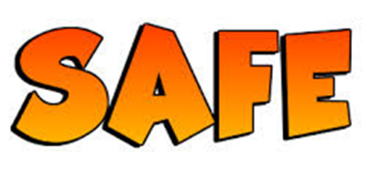
Join the Abbots Green SAFETY SQUAD
- We need 1 child from each year group to help us all keep safer in school.
- We will try to make it safer for us outside of school – e.g at the park.
- We will think of ways to help people stay safe online
- We will work with parents
- We will talk to people in our community e.g. the police; local shops
- We will meet every week – sometimes this will be at lunchtimes.
DO YOU HAVE THE RAINBOW VALUES THAT WE NEED? Applications to Mrs Uttley by Friday 6th October
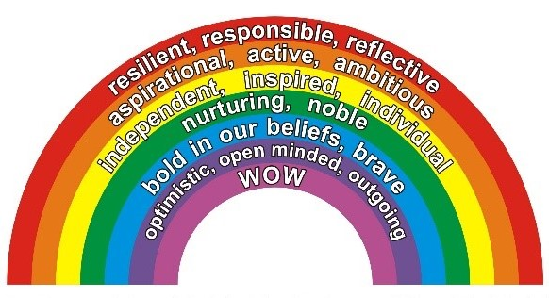
Now
Everyone
Makes
Our School Safe
I want to be part of the Abbots Green Safety Squad because:

Name: Class:

